

# *UniX and Linux Essentials*

**ASSIGNMENT - 7**

**SUBMITTED BY:**

**AYUSH KUMAR JHA**

**SAP ID - 500086400**

**Enrollment no - R200220083**

**B.C.A -I.O.T.**

**Assignment 7: -**

**Vim :-**

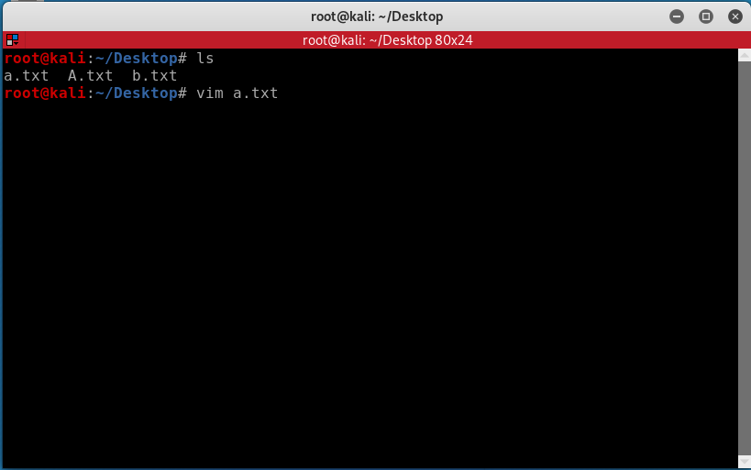

**Use I to insert**

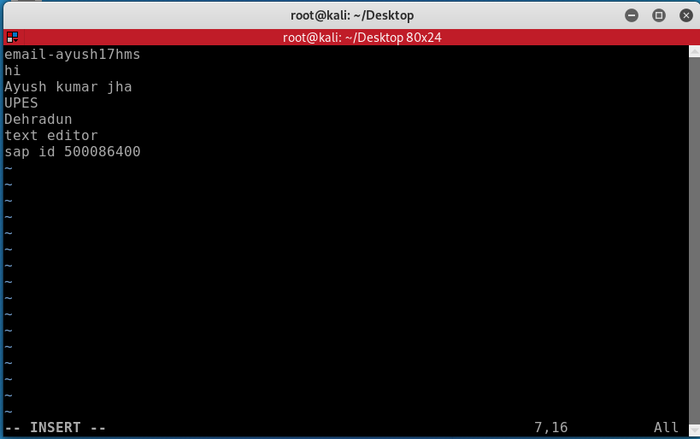

-I -(insert)

-ZZ,wq -(Saving and quit)

-ZQ –(quit without save)

-q! -(cancel the saving)

-w (save)

- view -(to view the file)

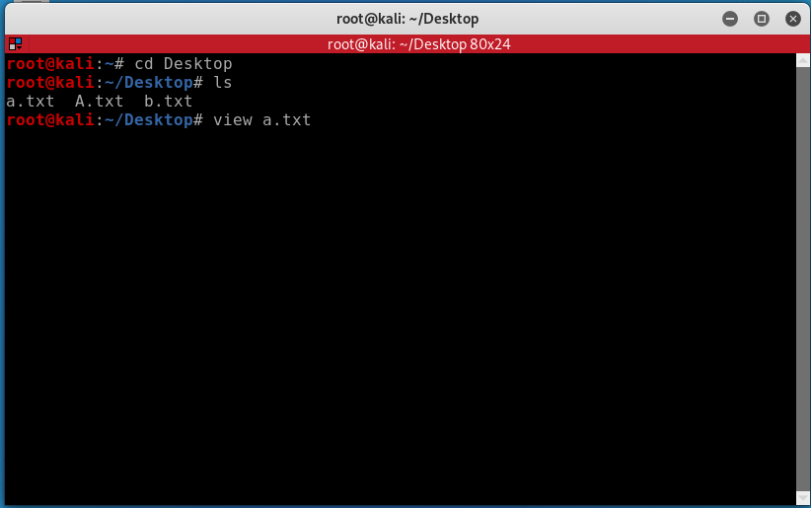

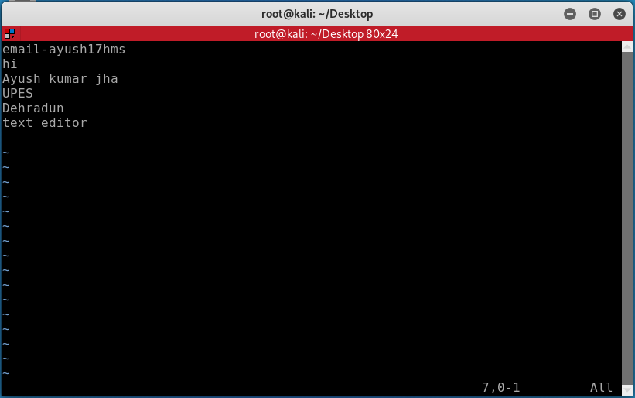

-/(word) -Search

